Physical Function and Depression in Breast, Colorectal, and Prostate Cancer Survivors Following a 16-Week Circuit-Based Aerobic and Resistance Exercise Intervention

By Joseph Zhang Yap

A Dissertation
Submitted to the Sargent College of Health and Rehabilitation
Boston University
Mentored by Dr. Christina Dieli-Conwright

ABSTRACT
Physical Function and Depression in Breast, Colorectal, and Prostate Cancer Survivors Following a 16-Week Circuit-Based Aerobic and Resistance Exercise Intervention
By JOSEPH Z. YAP

Breast, colorectal, and prostate cancers are among the most common cancers in the United States, affecting thousands of families and individuals each year. The physical and mental toll cancer and chemotherapies take on the patients are incredibly high, often leading to a decline in physical function and an increased prevalence of depression. A new and emerging field of cancer treatment uses exercise to rehabilitate and, in some cases, prehabilitate cancer patients to blunt the damages cancer can have on the patient. This thesis centers around the hypothesis that a 16-week circuit-based aerobic and resistance-based aerobic and resistance exercise intervention will significantly improve physical function as shown using the short physical performance battery (SPPB) as well as decrease depressive scores shown by the center for epidemiological studies depression scale (CES-D). Furthermore, it is hypothesized that exercise-induced improvements in physical function are associated with reductions in depression.

ACKNOWLEDGEMENTS
I would like to first thank my mentor, Christina Dieli-Conwright, my laboratory manager, Mary K. Norris, and all my amazing co-workers for the incredible amount of patience, support, and guidance they have provided throughout the creation of this thesis and in the development of my career. I would also like to thank Dean Gael Orsmond and my advisor, Dr. Zikopoulos, for helping me through this process with their advice and encouragement. Finally, I would like to thank my family, and close friends Niko and Taylor for the unconditional support they have given me this past year in completing this thesis.

List of Abbreviations

AC - Attention Control Group
ACSM - American College of Sports Medicine
ADT - Androgen Deprivation Therapy
CBT - Cognitive Behavioral Therapy
CES-D - Center for Epidemiological Studies Depression Scale
CRF - Cancer Related Fatigue
EG - Exercise Group
PABAC - Physical Activity Barriers after Cancer scale
PTSD - Post Traumatic Stress Disorder
HIIT - High-Intensity Interval Training
${HR}_{Max}$- Maximum Heart Rate
MICT - Moderate Intensity Continuous Training
MCID - Minimal Clinical Important Difference
RPE - Rating of Perceived Exertion
SES - Socioeconomic Status
SF-36 – 36-Item Short Form Survey
SPPB - Short Physical Performance Battery
QoL - Quality of Life
VO_{2max} - Maximal Oxygen Consumption

OUTLINE

- Introduction
  - Epidemiological Data of Breast Cancer, Colorectal, and Prostate Cancer (6)
  - Physical Function During and After Cancer (9)
  - Depression Among Cancer Patients (8)
  - Exercise as Rehabilitation (10)

- Methods
  - The ACTIVATE Trial (12)
    - Overview of study design (12)
    - Participants (13)
    - Outcomes measured (14)
    - Exercise Intervention (15)
    - Attention Control Group (17)
    - Statistical Methods (17)

- Results
  - Descriptive statistics (18)
  - Depression (20)
  - Physical Function (21)
  - Correlations Between Physical Function and Depression (22)

- Discussion
  - Patient Characteristics (25)
  - Clinical Implications (26)

- Conclusion

- Appendix
  - Appendix A - SPSS Outputs (36)
  - Appendix B - CES-D Questionnaire (38)
  - Appendix C - SPPB Test Example (39)

INTRODUCTION

1.1 Epidemiological Data of Breast, Colorectal, and Prostate Cancer

Cancer is a disease that affects nearly 1.6 million people and takes over 600,000 lives per year [1]. Among cancers, breast, colorectal, and prostate cancers exist as the three most common solid tumors, and combined are estimated to affect 682,230 Americans and cause a devastating 126,500 deaths in 2022 [2].
Currently, in the United States, breast cancer exists as the most prevalent type of non-skin cancer in women, affecting 1 out of every 8 women at some point in their lives [3], and has become one of the most common cancers for women around the world [3]. Furthermore, of the 287,850 expected new cases in the United States in 2022, about 43,250 women are expected to pass away [3]. Of these women, the risk of developing breast cancer increases with age, socioeconomic status, exposure to environmental factors such as pollution or radiation [5] and is more common among minorities [6]. Along with the diagnosis of breast cancer comes a high probability of comorbidities, about 73% of patients and survivors present with at least one comorbidity, most commonly including hypertension, arthritis, and diabetes which often correlates with a significant decrease in quality of life (QoL) [7]. Furthermore, as advancements in treatment have steadily improved, the percentage of survivors has also risen, who also tend to exhibit a higher amount of comorbidities such as diabetes, osteoporosis, cardiovascular disease, and premature death [8].
Excluding skin cancers, colorectal cancer is currently the third most common cancer diagnosed in both men and women in the United States, with an estimated 106,180 new cases of colon cancer and 44,850 new cases of rectal cancer [9]. Furthermore, the risk of developing colorectal cancer is once again increased for several minority groups, including Black, Asian, Hispanic, and Pacific Islanders. In a similar way to breast cancer, there have been significant improvements to colorectal cancer treatment, which in turn increases the rate, the number of survivors (1.5 million in 2022), and the number of comorbidities [10].
Similar to breast and colorectal cancers, prostate cancer is one of the most prevalent forms of cancer, affecting 1 in 8 men throughout their lifetime. Furthermore, 268,490 new cases are expected to be diagnosed in 2022, and 34,500 deaths. Prostate cancer is also most prevalent and occurs at a younger age than the national average among African American and Caribbean men of African ancestry [11]. Additionally, a higher proportion of black men have at least 1 comorbid condition when compared to white men, most commonly genitourinary disease, hypertension, and musculoskeletal and connective tissue disorders [12]. Apart from cancer itself, the leading cause of death in prostate cancer patients and survivors is cardiovascular disease, which can be exacerbated by androgen deprivation therapy, a common treatment for prostate cancer [13].
Furthermore, there is a remarkedly high prevalence of obesity among cancer survivors, with about 30% of survivors meeting the criteria for obesity [14]. Obesity in prostate cancer results in an increased inflammatory environment, metabolic irregularities, poorer prognosis, increased reoccurrences and second cancers, and many more negative effects on a survivor’s life [15].
Although the increased number of comorbidities such as diabetes and cardiovascular disease is seen amongst these three cancers, their effects on mortality can be lessened through lifestyle interventions such as exercise and diet [16].
1.2 Physical Function During and After Cancer

Along with other comorbidities, cancer patients and survivors experience distinct drops in physical function: the ability to do everyday tasks such as walking, standing from sitting, and balance [17]. Physical function tends to especially decrease in elderly patients, who typically present with less lean mass at baseline and an already low physical function ability prior to chemotherapy [18]. Furthermore, the decrease in physical function can be majorly attributed to a significant loss in skeletal muscle, or lean mass, and results in weakness exacerbated by a lack of exercise and a sedentary lifestyle [19]. Cancer survivors specifically report higher incidences of falls [20] and functional limitations in comparison to healthy individuals which may lead to an increased risk of life-threatening injury among older and frail demographics [21]. During chemotherapy, patients can fall into a cycle initiated by cancer-related fatigue (CRF) where fatigue leads to sedentary behavior, which escalates physical deconditioning and muscle loss, accelerating losses in function, leading once again to even more fatigue [22].
A decline in physical fatigue amongst cancer patients often coincides with increased depressive scores, with some studies showing depressive scores peaking predominantly after treatment, leaving survivors especially vulnerable to decreases in physical and mental health if not given proper guidance on how to maintain or improve their condition [22]. Furthermore, it has been demonstrated that improvements in physical function and decreased pain correlate to reduced depressive scores [23]. A promising treatment targeting both physical function and depression among several other improved outcomes is exercise [24].

1.3 Depression Among Cancer Patients

One of the most common symptoms among cancer patients and survivors is depression, occurring in 15% - 25% of all patients and tends to affect both men and women with equal prevalence [25]. Depression caused by cancer is unique in comparison to other diseases, with studies showing that cancer diagnoses generate higher levels of distress than non-neoplastic diseases (noncancerous) even with poorer prognoses [26]. Depression itself has also been shown to leach into all aspects of the patient diagnosed with cancer, including higher non-suicide related mortality rates [27], increased inflammation and decreased immune function [28], recovery times and treatment effectiveness, and many more outcomes affecting the overall quality of life of the individual [29]. Furthermore, depression is often accompanied by psychiatric disorders such as anxiety, with one study showing a 38.2% prevalence of depression and a 32.2% prevalence of anxiety among a cohort of breast cancer patients [30].
With the COVID-19 pandemic, mental health has become a larger concern, with cancer patients particularly feeling its effects. An epidemiological study conducted around one of the initial surges of the pandemic found that 23.4% of cancer patients experienced symptoms of depression along with other conditions such as anxiety and post-traumatic stress disorder (PTSD). As a result, it was deduced that worries concerning the pandemic specifically have a significant effect on mental health status, as well as increasing the severity of existing conditions. However, despite the high prevalence and severity of depression among cancer patients and survivors, only 1.6% of the patients diagnosed were actively seeking psychological counseling [31]. As of now, depression has remained largely untreated and unconsidered in the rehabilitation of cancer patients, once again leading to poorer prognosis and life expectancies in patients and survivors.
One promising long-term treatment for depression in cancer patients and survivors is long-term use of exercise regimens such as high-intensity interval training (HIIT). Several studies have shown significant improvements in depressive symptoms and overall quality of life (QoL) [32][24], oftentimes coinciding with an improvement in physical function and several other outcomes which will be discussed later on.

1.4 Exercise as Rehabilitation

As mentioned before, exercise can play a pivotal role in the improvement of physical and mental health among cancer survivors. According to the guidelines set by the American College of Sports Medicine (ACSM), there is significant evidence that exercise is associated with longer survival among breast, colon, and prostate cancers. Furthermore, as of 2019, the ACSM recommends that cancer survivors exercise with medium intensity for 150 to 300 minutes a week or 75 to 150 minutes of vigorous activity (a rate of perceived exertion (RPE) of 6 or above) per week [33]. Exercise during chemotherapy itself has been shown to significantly decrease fatigue [34], and improve symptoms of chemotherapy-induced peripheral neuropathy (damage to the nerves outside the spine or brain) such as numbness and tingling [35], quality of life, and depression scores [36], alongside other general improvements in health and wellbeing.
For survivors, exercise has shown similar improvements in outcomes to those of cancer patients [26] and comes with a decreased mortality rate. One study found a 37% reduction in the rate of breast cancer-specific mortality and a 39% decrease in the all-cause mortality rate with the inclusion of moderate physical activity as part of one’s daily routine [37]. Furthermore, the current leading causes of death in cancer survivors are heart and cardiovascular diseases [38], which may be exacerbated by androgen deprivation therapy (ADT), a common treatment for prostate cancer [39]. Numerous studies have shown improvements in cardiovascular fitness and health following a multi-month exercise intervention in breast [40], colorectal [41], and prostate cancer survivors [42], helping to lower the risk of cardiovascular disease [13].
Currently, the two most researched clinical exercise interventions are high-intensity interval training (HIIT) and medium intensity continuous training (MICT). MICT involves maintaining a typically performed for a prolonged period of time within the medium-intensity domain [43]. MICT has been shown to improve body composition, cardiorespiratory fitness, cognition, physical function, depression, and more in both patients and survivors [44]. Although MICT does not improve VO_{2max} at the same rate as HIIT exercises do, its relatively low intensity allows for the individual to recover faster, and thus can be implemented more regularly in one’s daily life, and is superior in improving long-term glucose metabolism [44].
HIIT involves alternating bursts of higher intensity (>80% of maximal oxygen uptake [VO_{2max}] or >85% of maximal heart rate (${HR}_{Max}$) and lower intensity for active recovery [45]. HIIT has been shown to produce similar results in anthropomorphic outcomes such as body composition or body mass index (BMI) as MICT [45], however, is more effective in improving cardiovascular health and fitness [45]. Another added benefit of HIIT is its relatively short duration of exercise, allowing for similar results to be met in much shorter amounts of time [45].

Methods

2.1 The ACTIVATE Trial
2.2.1 Overview of study design

This study originally aimed to target metabolic dysregulation and overall survival rates in breast, colorectal, and prostate cancer survivors. The ACTIVATE trial (Aerobic and Resistance, Circuit-InTerval-Based Exercise In SurVivors of Breast, Prostate, And Colorectal Cancer to Target MEtabolic Dysregulation) was a two-armed randomized control trial that compared an exercise group (EG) receiving a 16-week circuit-based exercise intervention to an attention control group (AC) that performed the same stretching protocol as the exercise group. Endpoints were assessed at baseline, mid intervention (week 9), post-intervention (week 18), and at a 4-month follow-up (week 34, exercise group only). The full protocol and informed consent were approved by the institutional review board (0S-17-5) and registered with ClinicalTrials.gov.

2.1.2 Participants

To be considered eligible for this study, the participants must have met the following eligibility criteria:
- Men or Women newly diagnosed (Stage I-III) breast, prostate, or colorectal cancer
- Were overweight or obese with the following criteria
- BMI >25 kg/m^3 (upper limit BMI was not set, relied on physician clearance to assess full eligibility)
- Body fat >30%
- Waist circumference >35 in.
- Had undergone surgery to treat cancer
- Had completed cancer-related treatment within the past three years
- Spoke English or Spanish
- Were in cancer remission with no detectable disease present
- Participate in less than 60 minutes of structured exercise per week at the time of baseline assessments

Exclusion criteria were as follows:
- Patients with metastatic disease (BREAST AND COLORECTAL ONLY)
- Had not completed surgery, chemotherapy, or radiation treatment associated with their diagnosis; a washout period of a minimum of 6 weeks was required from the last anti-cancer treatment received except hormonal therapy
- Patients with a history of any musculoskeletal, cardiorespiratory or neurological diseases that precluded the participation in exercise must have been evaluated by their physician to assess if they were suitable to proceed with the study
- Were planning reconstructive surgery with flap repair during the trial and follow-up period
- Were unable to travel to the exercise facility at USC
Following assessment for eligibility and enrollment, participants were randomized into the exercise group (EG) or attention control group (AC). The protocols for both groups will be detailed later in this thesis.

2.1.3 Outcomes Measured

The primary outcomes analyzed for the purposes of this thesis are physical function as measured by the Short Physical Performance Battery (SPPB) and self-reported depression scores given by the Center for Epidemiological Studies-Depression questionnaire (CES-D). The short performance physical battery consists of a series of physical tests, including gait speed, chair stands, and balance tests [46]. Furthermore, demographic outcomes of, gender, BMI, diagnosis/stage of cancer, treatment, education, socioeconomic status (SES), race/ethnicity, and marital status were included.

2.1.4 Exercise intervention

This study introduced a novel type of exercise intervention in the form of a mixed aerobic and resistance circuit, which combined three distinct training regimens that individually have demonstrated success in modulating inflammatory factors and body composition in non-cancer populations. The first component was periodization, which is the manipulation of training variables to optimize training adaptations and performance, as well as prevents overtraining. Linear periodization is a form of periodization that gradually increases training intensity while gradually decreasing volume, allowing for improved transitioning into exercising. The second component was a combination of aerobic and resistance training, both of which have been shown to elicit significant improvements in lean body mass [46], physical function, and overall quality of life [17]. The third component was the utilization of circuit training, in which the participant continually moves on to another exercise following the completion of one. Completion of all exercises constituted a single set and was repeated for several sets. High-intensity circuit training has been shown to improve physical performance, cardiovascular fitness, upper and lower body strength, blood pressure, and several other outcomes in comparison to lower-intensity exercise [40].
The exercise prescription consisted of four mesocycles of about four weeks, which were further subdivided into microcycles of two weeks. The four mesocycles were split into categories of difficulty: preparatory, moderate intensity, vigorous intensity, and high intensity. Each exercise session involved the patient warming up with 5 minutes of low-intensity aerobic exercise, then concluded with a 5-minute stretching of major muscle groups. The exercise intervention consisted of 5 minutes on a treadmill at a set intensity (%${HR}_{Max}$) and volume (duration, sets), then transitioned to exercising the main muscle groups of the body using the following exercises: leg press, chest press, leg curl, seated row, leg extension, and shoulder press. The intensities and volumes prescribed per week are shown in Table 1.

Table 1. Periodization model for exercises in the CARE program.
Training Period | Resistance Exercise |  | Aerobic Exercise
Mesocycle  Microcycle | Intensity  (%1RM) | Volume  (repetitions, sets) | Intensity  (%${HR}_{Max}$) | Volume  (duration, sets)
Preparatory  Weeks 1-2  Weeks 3-4 | 60%  65% | 15 x3  12-15 x3 | 60%  65% | 5 min x3  5 min x3
Moderate Int.  Weeks 5-6  Weeks 7-8 | 70%  70-67% | 10-12 x3  10-12 x3 | 70%  75% | 5 min x4  5 min x4
Vigorous Int.  Weeks 9-10  Weeks 11-12 | 70%  75% | 10 x3  8-10 x3 | 80%  80% | 5 min x5  5 min x5
High int.  Weeks 13-14  Weeks 15-16 | 80%  83% | 8 x3  8 x3 | 85%  85% | 6 min x5  6 min x5
${HR}_{Max}$, heart rate max; RM, repetition maximum

2.1.5 Attention Control Group

Participants randomized to the AC group performed the same home-based stretching program as the exercise group. The stretching involved one set of 3-4 static stretching exercises held for 30 seconds, done three days per week. The stretching was implemented to aid in the standardization of interventions, and patients received an instructional video and were asked to complete weekly records of flexibility compliance and physical activity performed outside of the study.

2.1.6 Statistical Methods

The data from 20 participants (n=20) of the ACTIVATE TRIAL were compiled on a spreadsheet in Microsoft Excel, then analyzed using IBM SPSS. One-way ANOVAs were used to determine between-group significance and simple t-tests were used to analyze within-group significance. Finally, a Pearson’s correlation was conducted to analyze any correlations between physical function and depression.

Results

3.1 Descriptive Statistics

The demographic and disease characteristics of study participants are presented in Table 2. The mean age of participants was 57.1 years (range: 39-72). The mean BMI was 30.4 $kg/m^{2}$ (range: 24.8-35.27$kg/m^{2}$), with 13 participants surpassing the 30 $kg/m^{2}$ cutoff for obesity, and the remaining 7 falling in the 25.0 to <30 $kg/m^{2}$ overweight categories [47]. The mean height and weights were 65.4 (SD = 4.6) and 186.9 (SD = 31.1) for the EG and 65.1 (SD=4.3) and 183.4 (SD=26.3) for the AC respectively. All of the participants across both groups were either widowed (n=2) or married (n=18), split evenly between the EG and AC. All participants underwent surgery (N=20, 100%) and radiation therapy (N=20, 100%) There were no significant differences between groups for baseline data (Table 2). Adherence to exercise across all participants was 92.0%.

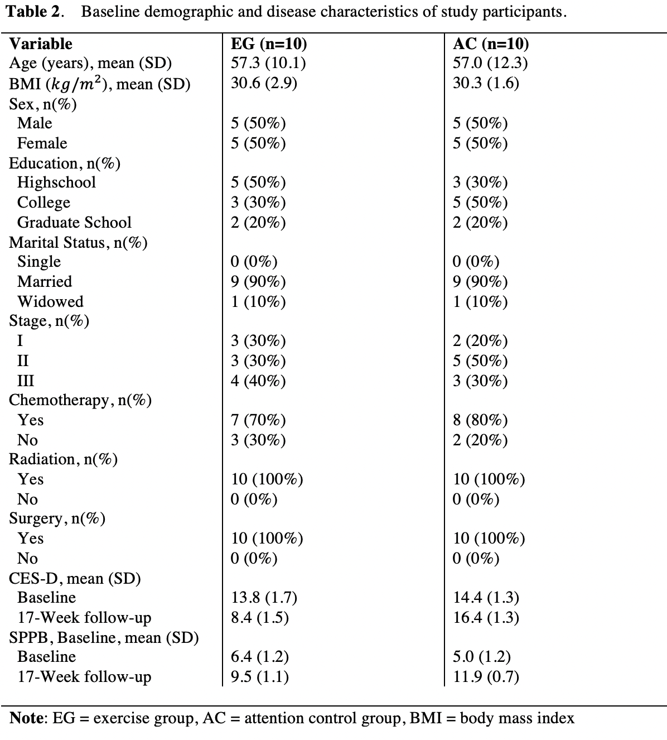

3.3 Physical Function (Figure 1)

The baseline mean scores for physical function were not statistically significant between groups (p=0.019). At week 17, the exercise group experienced a statistically significant increase in SPPB scores when compared to baseline (p<0.01) and the AC group (p=0.019). The EG met the criteria for the MCID for scores on the SPPB which is a >1 point increase [48].
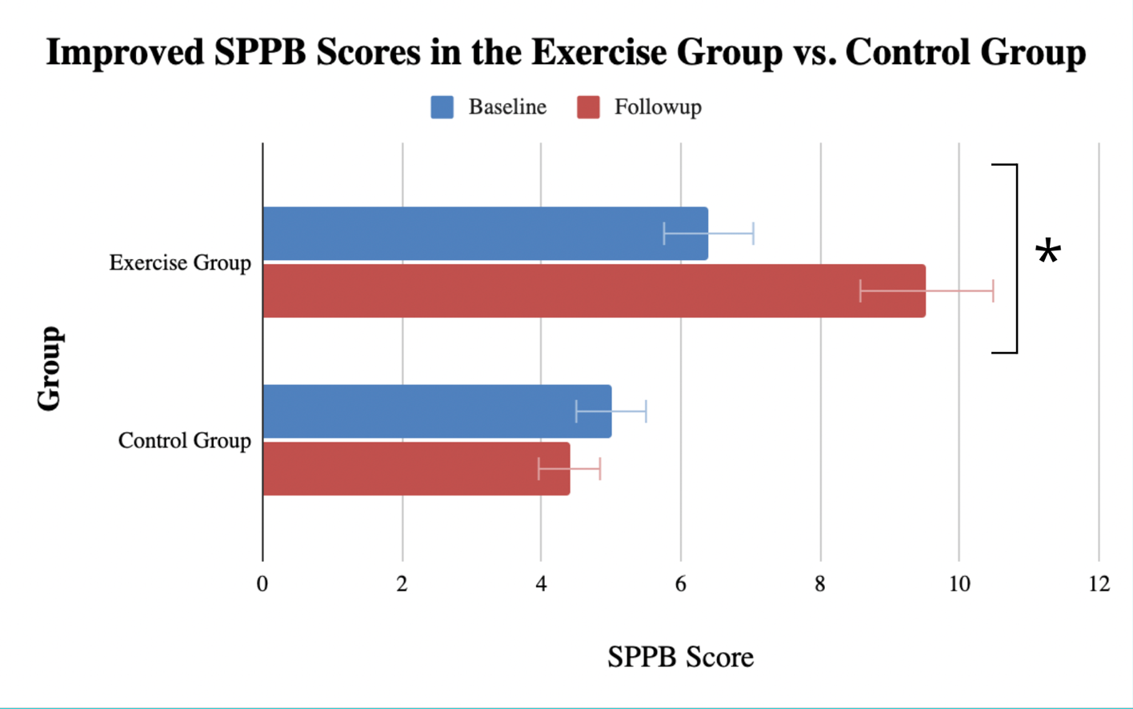
Figure 1. Baseline and Follow-up scores of the short physical performance battery in both the exercise and control groups. * Denotes statistically significant difference (p<0.05)

3.2 Depression (Figure 2)

The baseline mean values given by the CES-D indicate that there are no significant between-group differences (p=0.380). Both groups at baseline were below the criteria for depression (cutoff of 16) according to the CES-D scoring criteria. At week 17, when compared to the AC group, the exercise group had a significantly lower score, indicating lower levels of depression (p<0.001). The EG met the criteria for the minimal clinical important difference value (MCID) for scores on the CES-D, which is a 30% decrease in score [49].
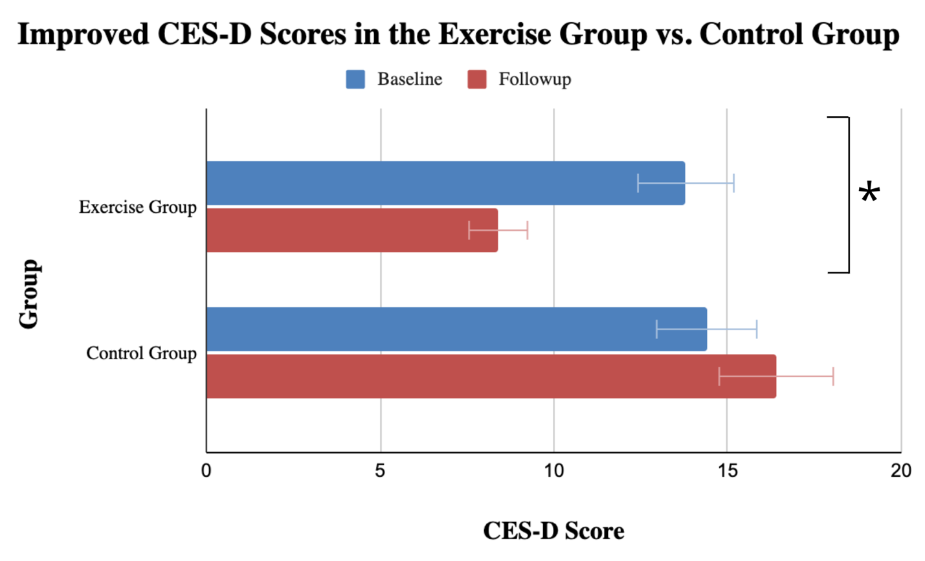
Figure 2. Baseline and Follow-up center for epidemiological studies - depression scale(CES-D) scores in both the exercise and control groups. * Denotes statistically significant difference (p<0.05)

3.4 Correlations Between Physical Function and Depression

Using a Pearson’s correlation, it was determined that changes in depression did not significantly correlate with physical function (r = .227, p=.529).
Discussion

Here we report the effect of a 16-week circuit-based exercise intervention on physical function and depression and subsequently the correlation between these two outcomes post-intervention. This trial led to statistically significant improvements in physical function and depression scores among participants randomized to the exercise intervention, yet exercise-induced changes in said outcomes were not associated with one another. Furthermore, according to the MCID for the CES-D and SPPB, the EG scores showed a clinically significant improvement in depression and physical function scores. These improvements in physical function and depression following exercise are consistent with previous studies [37][44].
Looking at the correlation between mean changes in physical function and depression, however, there does not seem to be a significant effect of one on the other. This indicates that exercise is the main catalyst of change for both physical function and depression, however, an increase in physical function does not independently improve depressive symptoms and vice versa. The lack of significance may be due to the relatively small sample size (N= 20), so further studies with larger sample sizes may be called for to see any possible effect physical function may have on depressive symptoms and vice versa. There are very few studies focusing on how changes in physical function affects depression specifically in cancer patients, however, previous studies focusing on the effects of physical function on depressive symptoms in post-acute cardiac patients found similar insignificance [49].
One study also using an aerobic and resistance training intervention observed statistically significant improvements in physical function along with global QoL, however, had several differences to our study. Some differences included that their trial spanned over 9 months compared to our 16 week intervention, they did not utilize circuit based exercise, and they utilized SF-36 derived patient reported physical function rather than SPPB derived scores. One strength of our trial in comparison to their trial was our ability to reach significant improvements in physical function in a much shorter intervention duration, which may be attributable to the circuit based training utilized [50].
Another study conducted also using an aerobic and resistance training intervention for cancer survivors showed varied outcomes in comparison to those of this trial. The EFICAN trial [51] was a 12-week resistance and aerobic exercise intervention for breast cancer patients, and although significant improvements in muscular strength were observed, there were no significant changes in CES-D scores from baseline within the exercise group. Some major differences in protocol between the EFICAN trial and the ACTIVATE trial is that exercises were not done in a circuit form, the trial duration was shorter, and participants transitioned from 1-on-1 supervised exercise in the first phase to a group based exercise intervention in the second phase. One potential cause of the insignificant changes in depressive scores that they noted was the relatively short study period, which can help to explain the significant changes seen in our 16 week intervention. Furthermore, participants in the EFICAN trial exercised twice per week, whereas our intervention prescribed three exercise sessions per week.
A major strength of this intervention is its utilization of both resistance and aerobic exercise, which have both independently elicited significant improvements in physical function [52][53] and depression [54][55]. It has been shown that combining resistance and aerobic exercise has elicited greater improvements in physical function and depression than either resistance or aerobic exercise alone [56]. Furthermore, this study utilized supervised 1 on 1 training by licensed exercise oncology trainers, which has proven to be more effective than group based or self-guided interventions at improving body composition, quality of life, and other fitness variables [57]. Another benefit of the trial was the flexibility of exercise timing: trainers were available at various times in the day which allowed participants to exercise according to their own schedule, which may have contributed to the high adherence (92%).
A weakness of this trial, however, is its ability to be extrapolated for individuals who may not have access to a personal trainer or appropriate exercise space. The nature of this intervention requires uninterrupted switching from exercise to exercise, and may not be feasible in a public exercise facility or gym. Recent studies, however, have shown that remote at-home exercise interventions are feasible and produce significant improvements in physical function and depression, removing the need for such an exercise facility [58]. In addition, a possible limitation of this study is the duration of intervention: although 16 weeks of exercise elicited significant improvements in physical function and depression, it does not factor in long term adherence to this intervention. Previous studies have illustrated that lower intensity exercise may be more sustainable, especially in older survivors who may have physical limitations [59][44].

4.1 Patient characteristics

When comparing the mean changes in depression and physical function between different racial identities of the exercise group, there was no statistical significance found which, once again, may be the result of a small sample size (N= 20). Previous studies have noted that along with the higher proportion of cancer diagnoses being seen in Black and Hispanic patients [12], a larger portion of these patients experience comorbidities, depression, and non-cancer-related mortality [60][61]. Furthermore, a study notes that the psychological well-being of Black cancer survivors specifically is not well studied, and that future exploration into culturally sensitive interventions can help to maintain or improve the quality of life in this population [60]. Future studies with larger sample sizes can explore the effects of exercise in minority populations.

4.2 Clinical Implications

Although exercise has been shown to elicit improvements in physical and mental health for cancer survivors, many cancer survivors report challenges in participating in physical activity [62]. In one study, 662 participants were administered the 12-item Physical Activity Barriers after Cancer scale (PABAC) which quantifies reasons for not participating in physical activity. This study found that some of the most common barriers to exercise include physical symptoms such as pain or surgical complications, but also environmental and psychological reasons such as lack of a safe space to exercise and sadness. A review focusing similarly on barriers to exercise indicated that not receiving information regarding how or why exercise is important may impact the number of survivors meeting physical activity recommendations [62]. This once again uncovers a weakness of the ACTIVATE trial, in which individuals may not be able to replicate this intervention due to a lack of an exercise facility. Furthermore, physicians in the future should properly advise survivors on the importance of exercise using data from trials like ACTIVATE.
Despite this study indicating improvements in depressive scores, there still exists a significant issue of not seeking help for mental illnesses among cancer survivors [32]. A potential reason for this may be a lack of access to behavioral therapy following the acute treatment phase. A recent group of randomized control trials conducted in 2021 showed improvement in depressive symptoms, cognition, and sleep disturbances in cancer survivors following a period of CBT [63]. Furthermore, a recent review of 36 studies has shown that pairing lifestyle changes and CBT shows significant improvements in health-related outcomes in comparison to usual care and CBT or lifestyle changes alone [64]. Future studies should continue to explore different exercise interventions paired with CBT’s effects on depression in survivors, as it can contribute to a well rounded lifestyle prescription following treatment.

Conclusion

Through this study, it was shown that a 16-week circuit-based resistance and exercise intervention results in statistically and clinically significant improvements in physical function and depression.

References

- Centers for Disease Control and Prevention. (2020, December 16). Cancer - CDC. Centers for Disease Control and Prevention. Retrieved from https://www.cdc.gov/chronicdisease/resources/publications/factsheets/cancer.htm
- Common cancer types. National Cancer Institute. (2021, April 22). Retrieved from https://www.cancer.gov/types/common-cancers#:~:text=The%20most%20common%20type%20of,are%20combined%20for%20the%20list
- Breast cancer statistics: How common is breast cancer? American Cancer Society. (2022, January 12). Retrieved from https://www.cancer.org/cancer/breast-cancer/about/how-common-is-breast-cancer.html
- World Health Organization. (2021, March 26). Breast cancer. World Health Organization. Retrieved from https://www.who.int/news-room/fact-sheets/detail/breast-cancer
- Momenimovahed, Z., & Salehiniya, H. (2019). Epidemiological Characteristics of and Risk Factors for Breast Cancer in the World. Breast Cancer: Targets and Therapy, Volume 11, 151–164. https://doi.org/10.2147/bctt.s176070
- Breast Cancer Facts and Statistics Breastcancer.org. Donate to support free resources and programming for people affected by breast cancer: https://give.breastcancer.org/give/294499/#!/donation/checkout?c_src=clipboard&c_src2=text-link. Breast cancer facts and statistics. (2022, March 10). Retrieved from https://www.breastcancer.org/symptoms/understand_bc/statistics
- Fu, M., Axelrod, D., Guth, A., Cleland, C., Ryan, C., Weaver, K., Qiu, J., Kleinman, R., Scagliola, J., Palamar, J., & Melkus, G. (2015). Comorbidities and quality of Life Among Breast Cancer Survivors: A prospective study. Journal of Personalized Medicine, 5(3), 229–242. https://doi.org/10.3390/jpm5030229
- Arneja, J., & Brooks, J. D. (2021). The impact of chronic comorbidities at the time of breast cancer diagnosis on quality of life, and emotional health following treatment in Canada. PLOS ONE, 16(8). https://doi.org/10.1371/journal.pone.0256536
- Colorectal cancer statistics: How common is colorectal cancer? American Cancer Society. (2022, January 12). Retrieved from https://www.cancer.org/cancer/colon-rectal-cancer/about/key-statistics.html
- Fass, O. Z., Poels, K. E., Qian, Y., Zhong, H., & Liang, P. S. (2020). Demographics predict stage III/IV colorectal cancer in individuals under age 50. Journal of Clinical Gastroenterology, 54(8), 714–719. https://doi.org/10.1097/mcg.0000000000001374
- Key statistics for prostate cancer: Prostate cancer facts. American Cancer Society. (2022, January 12). Retrieved from https://www.cancer.org/cancer/prostate-cancer/about/key-statistics.html
- Xiao, H., Tan, F., Goovaerts, P., Ali, A. A., Adunlin, G., Huang, Y., & Gwede, C. K. (2013). Construction of a Comorbidity Index for Prostate Cancer Patients Linking State Cancer Registry with Inpatient and Outpatient Data. J Registry Manag., 40(4).
- Elmehrath, A. O., Afifi, A. M., Al-Husseini, M. J., Saad, A. M., Wilson, N., Shohdy, K. S., Pilie, P., Sonbol, M. B., & Alhalabi, O. (2021). Causes of death among patients with metastatic prostate cancer in the US from 2000 to 2016. JAMA Network Open, 4(8). https://doi.org/10.1001/jamanetworkopen.2021.19568
- Centers for Disease Control and Prevention. (2021, May 12). Caring for Cancer Survivors: Obesity and wellness. Centers for Disease Control and Prevention. Retrieved from https://www.cdc.gov/cancer/survivors/health-care-providers/obesity-wellness.htm#:~:text=Overweight%20and%20obesity%20are%20associated%20with%20at%20least%2013%20types%20of%20cancer.&text=About%2030%25%20of%20cancer%20survivors%20have%20obesity
- Wilson, R. L., Taaffe, D. R., Newton, R. U., Hart, N. H., Lyons-Wall, P., & Galvāo, D. A. (2022, January). Obesity and Prostate Cancer: A Narrative Review. Critical reviews in oncology/hematology. https://doi.org/10.1016/j.critrevonc.2021.103543
- Sun, C., Li, K., Xu, H., Wang, X., Qin, P., Wang, S., Liang, B., & Xu, L. (2021). Association of Healthy Lifestyle score with all-cause mortality and life expectancy: A city-wide prospective cohort study of cancer survivors. BMC Medicine, 19(1). https://doi.org/10.1186/s12916-021-02024-2
- Hong, Y., Wu, C., & Wu, B. (2020). Effects of resistance exercise on symptoms, physical function, and quality of life in gastrointestinal cancer patients undergoing chemotherapy. Integrative Cancer Therapies, 19, 153473542095491. https://doi.org/10.1177/1534735420954912
- Torstveit, A. H., Løyland, B., Grov, E. K., Guren, M., Paul, S. M., Ritchie, C., Vistad, I., Miaskowski, C., & Utne, I. (2021). Distinctions between self-report and performance-based measures of physical function in older patients prior to chemotherapy. Cancer Nursing, 44(6). https://doi.org/10.1097/ncc.0000000000000964
- Naito, T., Okayama, T., Aoyama, T. et al. Skeletal muscle depletion during chemotherapy has a large impact on physical function in elderly Japanese patients with advanced non–small-cell lung cancer. BMC Cancer 17, 571 (2017). https://doi.org/10.1186/s12885-017-3562-4
- Campbell, G., Wolfe, R. A., & Klem, M. L. (2018). Risk Factors for Falls in Adult Cancer Survivors: An Integrative Review. Rehabilitation nursing : the official journal of the Association of Rehabilitation Nurses, 43(4), 201–213. https://doi.org/10.1097/rnj.0000000000000173
- Winters-Stone, K.M., Dobek, J., Bennett, J.A. et al. The effect of resistance training on muscle strength and physical function in older, postmenopausal breast cancer survivors: a randomized controlled trial. J Cancer Surviv6, 189–199 (2012). https://doi.org/10.1007/s11764-011-0210-x
- Piraux, E., Caty, G., Aboubakar Nana, F., & Reychler, G. (2020). Effects of exercise therapy in cancer patients undergoing radiotherapy treatment: A narrative review. SAGE Open Medicine, 8, 205031212092265. https://doi.org/10.1177/2050312120922657
- Beleckas, C. M., Guattery, J., Chamberlain, A. M., Khan, T., Kelly, M. P., & Calfee, R. P. (2018). Using patient-reported outcomes measurement information system measures to understand the relationship between improvement in physical function and depressive symptoms. Journal of the American Academy of Orthopaedic Surgeons, 26(24). https://doi.org/10.5435/jaaos-d-17-00039
- Cartmel, B., Hughes, M., Ercolano, E. A., Gottlieb, L., Li, F., Zhou, Y., Harrigan, M., Ligibel, J. A., von Gruenigen, V. E., Gogoi, R., Schwartz, P. E., Risch, H. A., Lu, L., & Irwin, M. L. (2021). Randomized trial of exercise on depressive symptomatology and Brain Derived Neurotrophic Factor (BDNF) in Ovarian Cancer Survivors: The women's activity and Lifestyle Study in Connecticut (WALC). Gynecologic Oncology, 161(2), 587–594. https://doi.org/10.1016/j.ygyno.2021.02.036
- Depression (PDQ®)–health professional version. National Cancer Institute. (2022, April 19). Retrieved from https://www.cancer.gov/about-cancer/coping/feelings/depression-hp-pdq#section_1.1
- Smith, H. R. (2015). Depression in cancer patients: Pathogenesis, implications and treatment (review). Oncology Letters, 9(4), 1509–1514. https://doi.org/10.3892/ol.2015.2944
- Zhu, J., Wang, F., Shi, L., Cai, H., Zheng, Y., Zheng, W., Bao, P., & Shu, X.-O. (2020). Accelerated aging in breast cancer survivors and its association with mortality and cancer recurrence. Breast Cancer Research and Treatment, 180(2), 449–459. https://doi.org/10.1007/s10549-020-05541-5
- Beurel, E., Toups, M., & Nemeroff, C. B. (2020). The bidirectional relationship of depression and inflammation: Double trouble. Neuron, 107(2), 234–256. https://doi.org/10.1016/j.neuron.2020.06.002
- Niedzwiedz, C. L., Knifton, L., Robb, K. A., Katikireddi, S. V., & Smith, D. J. (2019). Depression and anxiety among people living with and beyond cancer: A growing clinical and research priority. BMC Cancer, 19(1). https://doi.org/10.1186/s12885-019-6181-4
- Tsaras, K., Papathanasiou, I. V., Mitsi, D., Veneti, A., Kelesi, M., Zyga, S., & Fradelos, E. C. (2018). Assessment of Depression and Anxiety in Breast Cancer Patients: Prevalence and Associated Factors. Asian Pac J Cancer Prevention, 19(6). https://doi.org/10.22034/APJCP.2018.19.6.1661.
- Wang, Y., Duan, Z., Ma, Z., Mao, Y., Li, X., Wilson, A., Qin, H., Ou, J., Peng, K., Zhou, F., Li, C., Liu, Z., & Chen, R. (2020). Epidemiology of mental health problems among patients with cancer during COVID-19 pandemic. Translational Psychiatry, 10(1). https://doi.org/10.1038/s41398-020-00950-y
- Aydin, M., Kose, E., Odabas, I., Meric Bingul, B., Demirci, D., & Aydin, Z. (2021). The effect of exercise on life quality and depression levels of breast cancer patients. Asian Pacific Journal of Cancer Prevention, 22(3), 725–732. https://doi.org/10.31557/apjcp.2021.22.3.725
- Campbell, K. L., Winters-Stone, K. M., Wiskemann, J., May, A. M., Schwartz, A. L., Courneya, K. S., Zucker, D. S., Matthews, C. E., Ligibel, J. A., Gerberr, L. H., Morris, S. G., Patel, A. V., Hue, T. F., Perna, F. M., & Schmitz, K. H. (2019). Exercise guidelines for cancer survivors: Consensus statement from international multidisciplinary roundtable. Medicine & Science in Sports & Exercise, 51(11), 2375–2390. https://doi.org/10.1249/mss.0000000000002116
- Medeiros Torres, D., Jorge Koifman, R. & da Silva Santos, S. Impact on fatigue of different types of physical exercise during adjuvant chemotherapy and radiotherapy in breast cancer: systematic review and meta-analysis. Support Care Cancer 30, 4651–4662 (2022). https://doi.org/10.1007/s00520-022-06809-w
- Tanay, M.A.L., Armes, J., Moss-Morris, R. et al. A systematic review of behavioural and exercise interventions for the prevention and management of chemotherapy-induced peripheral neuropathy symptoms. J Cancer Surviv (2021). https://doi.org/10.1007/s11764-021-00997-w
- Lopez, P., Taaffe, D.R., Newton, R.U. et al. What is the minimal dose for resistance exercise effectiveness in prostate cancer patients? Systematic review and meta-analysis on patient-reported outcomes. Prostate Cancer Prostatic Dis 24, 465–481 (2021). https://doi.org/10.1038/s41391-020-00301-4
- Medeiros Torres, D., Jorge Koifman, R. & da Silva Santos, S. Impact on fatigue of different types of physical exercise during adjuvant chemotherapy and radiotherapy in breast cancer: systematic review and meta-analysis. Support Care Cancer 30, 4651–4662 (2022). https://doi.org/10.1007/s00520-022-06809-w
- Oh, C. M., Lee, D., Kong, H. J., Lee, S., Won, Y. J., Jung, K. W., & Cho, H. (2020). Causes of death among cancer patients in the era of cancer survivorship in Korea: Attention to the suicide and cardiovascular mortality. Cancer Medicine, 9(5), 1741–1752. https://doi.org/10.1002/cam4.2813
- Zareba, P., Duivenvoorden, W., Leong, D. P., & Pinthus, J. H. (2015). Androgen deprivation therapy and cardiovascular disease: What is the linking mechanism? Therapeutic Advances in Urology, 8(2), 118–129. https://doi.org/10.1177/1756287215617872
- Jones, L. M., Stoner, L., Baldi, J. C., & McLaren, B. (2020). Circuit resistance training and cardiovascular health in Breast Cancer Survivors. European Journal of Cancer Care, 29(4). https://doi.org/10.1111/ecc.13231
- Zopf, E.M., Schulz, H., Poeschko, J. et al. Effects of supervised aerobic exercise on cardiorespiratory fitness and patient-reported health outcomes in colorectal cancer patients undergoing adjuvant chemotherapy—a pilot study. Support Care Cancer 30, 1945–1955 (2022). https://doi.org/10.1007/s00520-021-06608-9
- Kang, D.-W., Fairey, A. S., Boulé, N. G., Field, C. J., Wharton, S. A., & Courneya, K. S. (2021). Effects of exercise on cardiorespiratory fitness and biochemical progression in men with localized prostate cancer under active surveillance. JAMA Oncology, 7(10), 1487. https://doi.org/10.1001/jamaoncol.2021.3067
- Jannetta, D., Inglis, E. C., Mattu, A. T., Fontana, F. Y., Pogliaghi, S., Keir, D. A., & Murias, J. M. (2020). A critical evaluation of current methods for exercise prescription in women and men. Medicine & Science in Sports & Exercise, 52(2), 466–473. https://doi.org/10.1249/mss.0000000000002147
- Hooshmand Moghadam, B., Golestani, F., Bagheri, R., Cheraghloo, N., Eskandari, M., Wong, A., Nordvall, M., Suzuki, K., & Pournemati, P. (2021). The effects of high-intensity interval training vs. moderate-intensity continuous training on inflammatory markers, body composition, and physical fitness in overweight/obese survivors of breast cancer: A randomized controlled clinical trial. Cancers, 13(17), 4386. https://doi.org/10.3390/cancers13174386
- Mattoni Maturana, F., Martus, P., Zipfel, S., & Nieß, A. M. (2020). Effectiveness of HIIE versus MICT in improving cardiometabolic risk factors in health and disease: A meta-analysis. Medicine & Science in Sports & Exercise, 53(3), 559–573. https://doi.org/10.1249/mss.0000000000002506
- Pavasini, R., Guralnik, J., Brown, J. C., di Bari, M., Cesari, M., Landi, F., Vaes, B., Legrand, D., Verghese, J., Wang, C., Stenholm, S., Ferrucci, L., Lai, J. C., Bartes, A. A., Espaulella, J., Ferrer, M., Lim, J. Y., Ensrud, K. E., Cawthon, P., Turusheva, A., … Campo, G. (2016). Short Physical Performance Battery and all-cause mortality: systematic review and meta-analysis. BMC medicine, 14(1), 215. https://doi.org/10.1186/s12916-016-0763-7
- Centers for Disease Control and Prevention. (2021, June 7). Defining adult overweight & obesity. Centers for Disease Control and Prevention. Retrieved April 27, 2022, from https://www.cdc.gov/obesity/basics/adult-defining.html?CDC_AA_refVal=https%3A%2F%2Fwww.cdc.gov%2Fobesity%2Fadult%2Fdefining.html
- Rinaldo, L., Caligari, M., Acquati, C., Nicolazzi, S., Paracchini, G., Sardano, D., Giordano, A., Marcassa, C., & Corrà, U. (2021). Functional capacity assessment and Minimal Clinically Important Difference in post-acute cardiac patients: the role of Short Physical Performance Battery. European journal of preventive cardiology, zwab044. Advance online publication. https://doi.org/10.1093/eurjpc/zwab044
- Haase, I., Winkeler, M., & Imgart, H. (2016). Ankerbasierte Ermittlung klinisch relevanter Veränderung depressiver Symptomatik am Beispiel der Kurzform der CES-D [Anchor-based ascertaining of meaningful changes in depressive symptoms using the example of the German short form of the CES-D]. Neuropsychiatrie : Klinik, Diagnostik, Therapie und Rehabilitation : Organ der Gesellschaft Osterreichischer Nervenarzte und Psychiater, 30(2), 82–91. https://doi.org/10.1007/s40211-016-0184-z
- Paulo, T. R., Rossi, F. E., Viezel, J., Tosello, G. T., Seidinger, S. C., Simões, R. R., de Freitas, R., & Freitas, I. F. (2019). The impact of an exercise program on quality of life in older breast cancer survivors undergoing aromatase inhibitor therapy: A randomized controlled trial. Health and Quality of Life Outcomes, 17(1). https://doi.org/10.1186/s12955-019-1090-4
- Soriano-Maldonado, A., Díez-Fernández, D.M., Esteban-Simón, A. et al. Effects of a 12-week supervised resistance training program, combined with home-based physical activity, on physical fitness and quality of life in female breast cancer survivors: the EFICAN randomized controlled trial. J Cancer Surviv (2022). https://doi.org/10.1007/s11764-022-01192-1
- Beleckas, C. M., Guattery, J., Chamberlain, A. M., Khan, T., Kelly, M. P., & Calfee, R. P. (2018). Using patient-reported outcomes measurement information system measures to understand the relationship between improvement in physical function and depressive symptoms. Journal of the American Academy of Orthopaedic Surgeons, 26(24). https://doi.org/10.5435/jaaos-d-17-00039
- Serra, M. C., Ryan, A. S., Ortmeyer, H. K., Addison, O., & Goldberg, A. P. (2018). Resistance training reduces inflammation and fatigue and improves physical function in older breast cancer survivors. Menopause (New York, N.Y.), 25(2), 211–216. https://doi.org/10.1097/GME.0000000000000969
- Brown, J. C., Damjanov, N., Courneya, K. S., Troxel, A. B., Zemel, B. S., Rickels, M. R., Ky, B., Rhim, A. D., Rustgi, A. K., & Schmitz, K. H. (2018). A randomized dose-response trial of aerobic exercise and health-related quality of life in colon cancer survivors. Psycho-Oncology, 27(4), 1221–1228. https://doi.org/10.1002/pon.4655
- Steindorf, K., Schmidt, M. E., Klassen, O., Ulrich, C. M., Oelmann, J., Habermann, N., Beckhove, P., Owen, R., Debus, J., Wiskemann, J., & Potthoff, K. (2014). Randomized, controlled trial of resistance training in breast cancer patients receiving adjuvant radiotherapy: Results on cancer-related fatigue and quality of life. Annals of Oncology, 25(11), 2237–2243. https://doi.org/10.1093/annonc/mdu374
- Dieli-Conwright, C.M., Courneya, K.S., Demark-Wahnefried, W. et al. (2018) Aerobic and resistance exercise improves physical fitness, bone health, and quality of life in overweight and obese breast cancer survivors: a randomized controlled trial. Breast Cancer Res 20, 124. https://doi.org/10.1186/s13058-018-1051-6
- Storer, T. W., Dolezal, B. A., Berenc, M. N., Timmins, J. E., & Cooper, C. B. (2014). Effect of supervised, periodized exercise training vs. self-directed training on lean body mass and other fitness variables in health club members. Journal of strength and conditioning research, 28(7), 1995–2006. https://doi.org/10.1519/JSC.0000000000000331
- Gehring, K., Kloek, C. J. J., Aaronson, N. K., Janssen, K. W., Jones, L. W., Sitskoorn, M. M., & Stuiver, M. M. (2017). Feasibility of a home-based exercise intervention with remote guidance for patients with Stable Grade II and III gliomas: A pilot randomized controlled trial. Clinical Rehabilitation, 32(3), 352–366. https://doi.org/10.1177/0269215517728326
- Grimmett, C., Corbett, T., Brunet, J. et al. Systematic review and meta-analysis of maintenance of physical activity behaviour change in cancer survivors. Int J Behav Nutr Phys Act 16, 37 (2019). https://doi.org/10.1186/s12966-019-0787-4
- Dickey, S. L., & Ogunsanya, M. E. (2018). Quality of Life Among Black Prostate Cancer Survivors: An Integrative Review. American journal of men's health, 12(5), 1648–1664. https://doi.org/10.1177/1557988318780857
- Ramirez, A. G., Gallion, K. J., Perez, A., Munoz, E., Long Parma, D., Moreno, P. I., & Penedo, F. J. (2019). Improving quality of life among latino cancer survivors: Design of a randomized trial of patient navigation. Contemporary clinical trials, 76, 41–48. https://doi.org/10.1016/j.cct.2018.11.002
- Clifford, B.K., Mizrahi, D., Sandler, C.X. et al. Barriers and facilitators of exercise experienced by cancer survivors: a mixed methods systematic review. Support Care Cancer 26, 685–700 (2018). https://doi.org/10.1007/s00520-017-3964-5
- Müller, F., Wijayanto, F., Abrahams, H., Gielissen, M., Prinsen, H., Braamse, A., Laarhoven, H. W. M., Groot, P., Heskes, T., & Knoop, H. (2021). Potential mechanisms of the fatigue‐reducing effect of cognitive‐behavioral therapy in cancer survivors: Three randomized controlled trials. Psycho-Oncology, 30(9), 1476–1484. https://doi.org/10.1002/pon.5710
- Addison, S., Shirima, D., Aboagye-Mensah, E.B. et al. Effects of tandem cognitive behavioral therapy and healthy lifestyle interventions on health-related outcomes in cancer survivors: a systematic review. J Cancer Surviv (2021). https://doi.org/10.1007/s11764-021-01094-8

Appendix
Appendix A - SPSS outputs

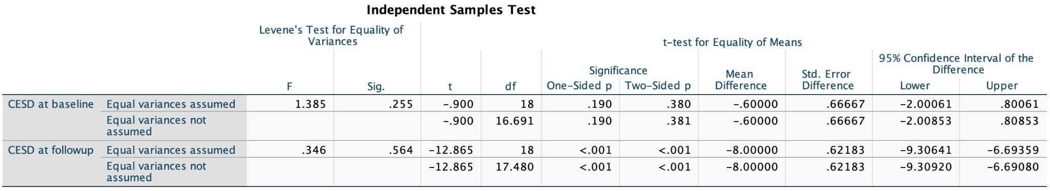
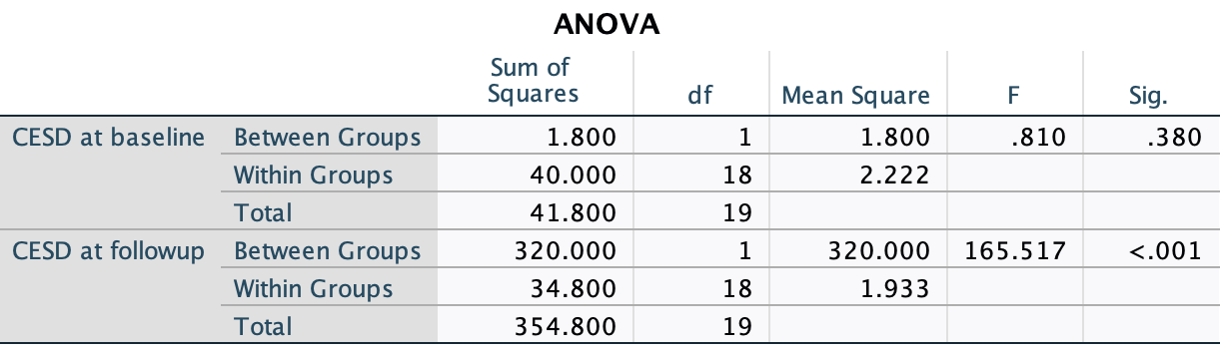

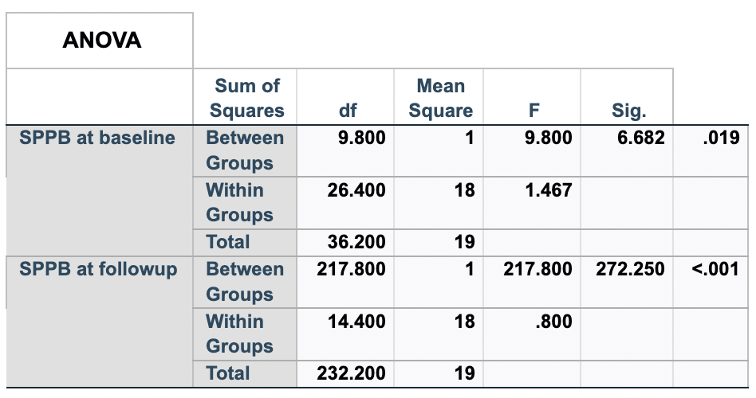
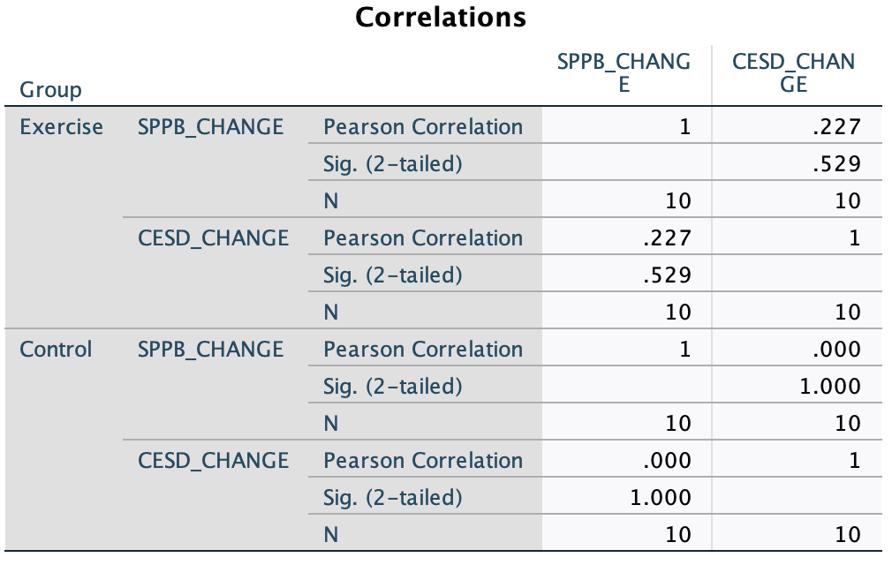

Appendix B - CES-D Questionnaire

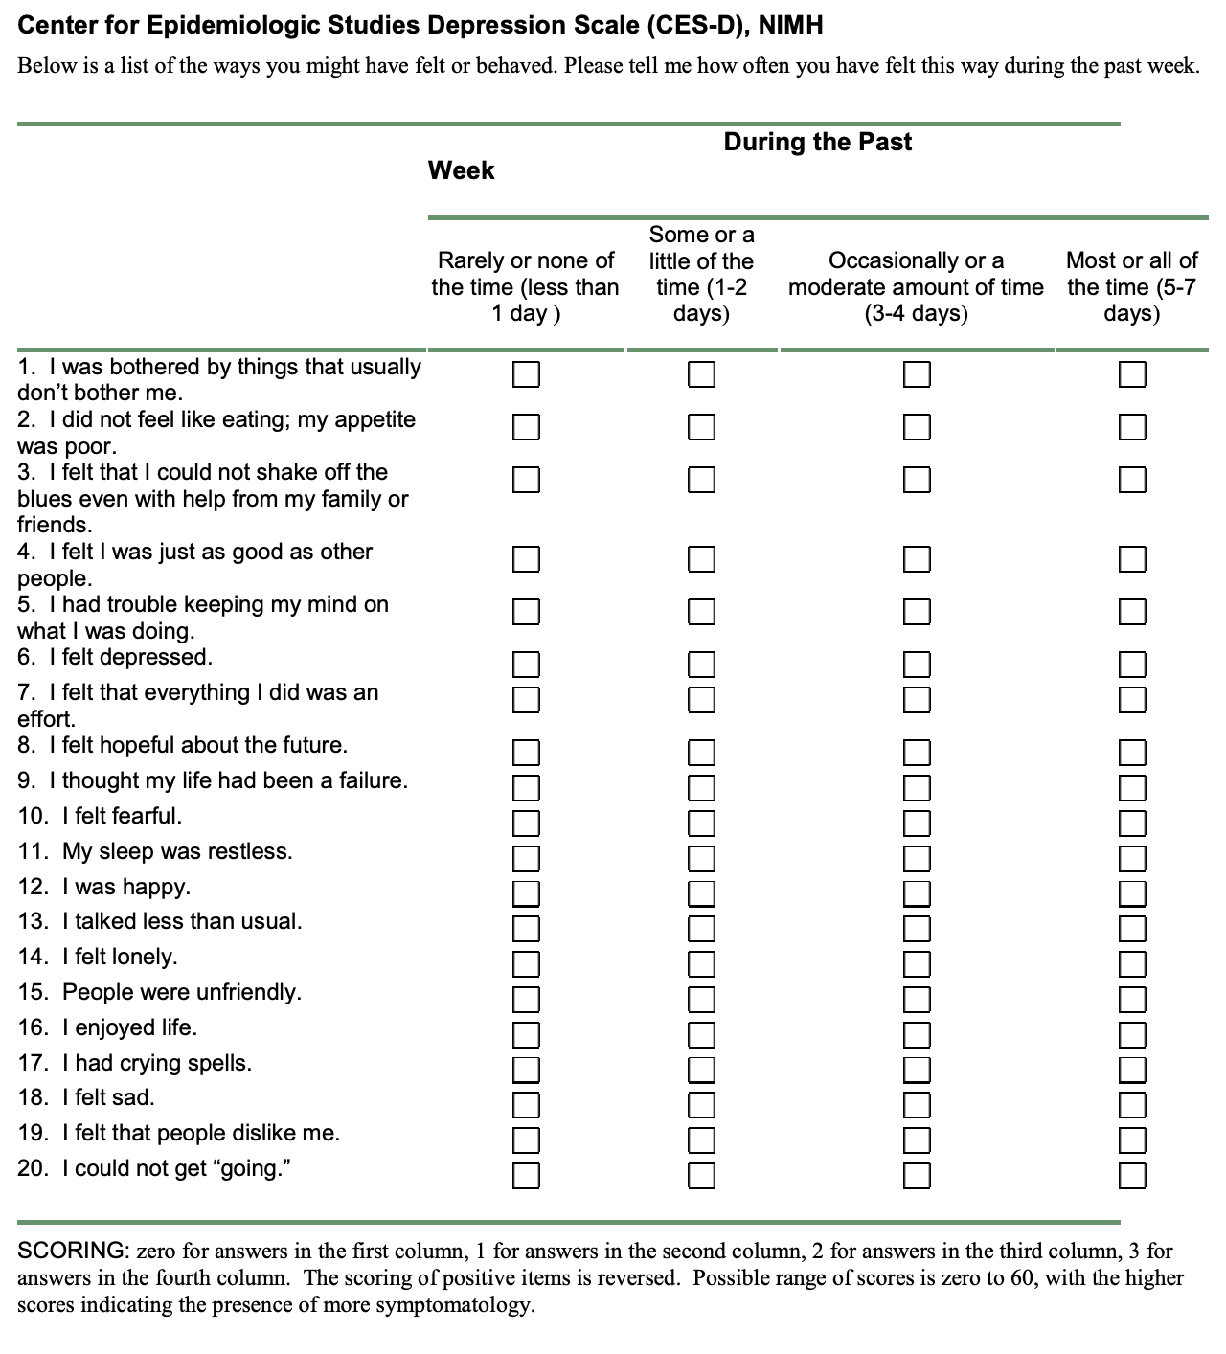

Appendix C - SPPB Example

